## horizontal line

Trade Car Platform

20/05/2022

**─**

AutoGuru Ireland Ltd

Unit W4H

Ladytown,

Newhall,

Naas

# Project Objective

The primary objective is to build a website where car dealers will be able to place offers on cars on a timed sale. The buyers will be able to register and login onto the website to see details on the car and place their offers. Admin will be able to manage the website content from the backend

Example of websites:

https://www.dealerauction.co.uk/

<https://tradesales.ie/>

Note: Car Dealers are referred to as User going forward

# 

# Scope of Work

|  | **Item** | **User** | **Device/Platform** |
| --- | --- | --- | --- |
| 1 | Frontend | Frontend User | Desktop/Tablet/Mobile |
| 2 | Web Admin Panel | Admin | Desktop |

# System Features

# Frontend Features

1. About Us
2. Header
3. Logo
4. Menu Navigation

i. Home

ii. Stock

iii. FAQ

iv. Reports

V. My Account

Vi. Dashboard

1. Banner and Images (Slider)
2. Text areas
3. Carousel of highlighted stock - Selectable by admin
4. Login / Register

## 

## Designs

* The main design theme has been paid for and edited, some small changes / tweeks will be needed as we go onwards i.e additional text boxes / images but nothing affecting flows / structures.

## Sign Offs

All changes to the site must be signed off before development and deployment is started (to avoid reworks and additional hours) .

## Register

The User will be able to register on the website by providing the following details:

* Name (Required)
* Dealership name (Required)
* Website link (Optional)
* Email Address (Required)
* Vat registered (Required)
* Garage code (Required)
* What Bank Used (Required)
* Password
* Confirm Password

The user will receive an email stating their account is in review. Admin will approve any registrations and activate the users manual.

## Sign-In

Once the user has registered they will be able to login and validate credentials.

The user will have to provide the following details to login:

* + - Email ID
    - Password

Forgot password: The website will have a feature for when the user forgets his password, the user can click on “forgot password”, the user will be redirected to the page with the message: “Please enter your email address” and with the form including:

* + - Email id
    - Submit

The user will receive a password reset link on his/her email id through which he/she’ll be able to reset his/her password.

## User logged in

After login the user will be able to see details not on public view. View condition report on vehicles, view mechanical reports on vehicle, see guide price, place an offer on a vehicle, the bid will only be seen by the Admin and not by other front end users.

User Dashboard

* The user will be able to see vehicles they have placed offers on, those that they have successfully secured by being the highest offer.
* Update their personal information

FAQ

* All text / headings on listing and images will need to be editable in the admin panel.

## Contact

* General contact us page, dropdown to select section i.e (additional may be added) Registration, General Enquiry, Claim.
* Contacts feeding to email.

## Admin / Backend Features

* User management:
  + - * + Admin will need to be able to view who is active /deactivate, add / delete users.
        + See what each user has bid on a particular vehicle.
* Content Management: Admin will be able to add, edit and delete the content of the pages on the site.
* Listing (Stock) content management: Admin will be able to add the listings for each vehicle, attached pdf report of the mechanical and conditional report to each listing.
* Admin will need to be able to see who the highest offer on each car is

## Content Management

* All main Text boxes / Images on the site will need to be editable on the admin panel.

## Stock / Listings

* Details on each car uploaded by admin will show
* Each listing will have the ability to have 10 images uploaded.
* Each listing will have a pdf of a mechanical report and a pdf of a condition report (Examples will be shown on our calls) these will only be seen when the user has logged in.
* Timer will show on each listing of how long is left for the vehicle sale (Editable by the admin)
* Each vehicle will have a buy now where the seller can accept a price to purchase the vehicle and end the sale (Admin will set the buy now price)
* After selecting buy now the user will be directed to a confirmation page.
* After a vehicle has had a buy now offer confirmed it will be marked as Sold on the listing until the admin removes it.

Visible Vehicle Details **before** login

* Heading and main image will show on the stock page

After clicking in to the listing:

Make / Model, Engine Size, Transmission, Mileage, Fuel

Visible Vehicle Details **after** login

* Mechanical and conditional report will be show and clickable to open
* Estimated price will be displayed
* Buy now price will be displayed
* User will be able to make an offer
* User will be able to click buy now

Mobile Optimisation

* Site will need to be optimised for both Desktop and Mobile

On going maintenance

* After completion we will launch the site and compile changes to be made (seperate new invoice depending on scope of changes)
* We will also like to come to an agreement on continued maintenance on the site 2

**User register/login**

**-register page**

The below looks perfect, can you add one more box to the below

“DoneDeal Dealer Hub ID”

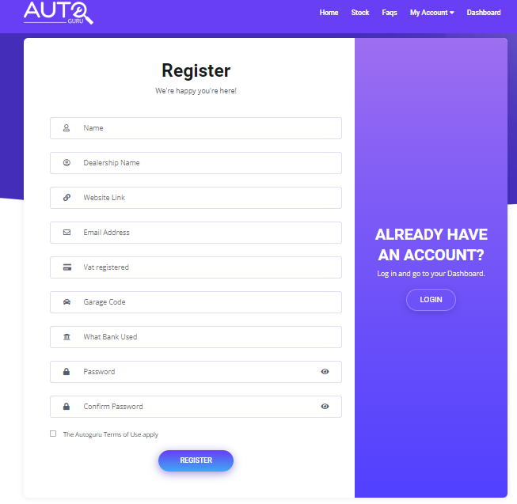

* **login page**

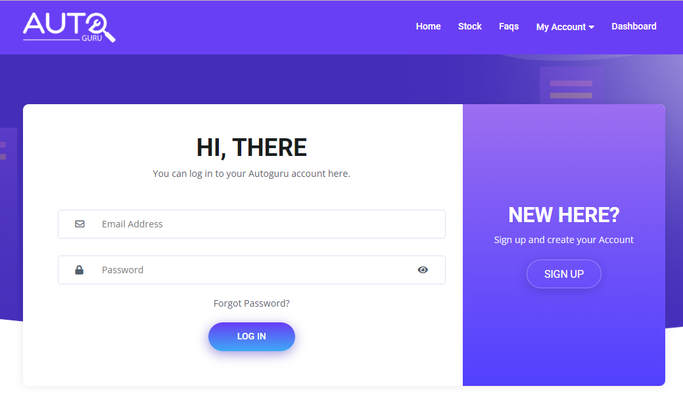

**User dashboard**

Users will be able to edit their personnel infos using the edit button.

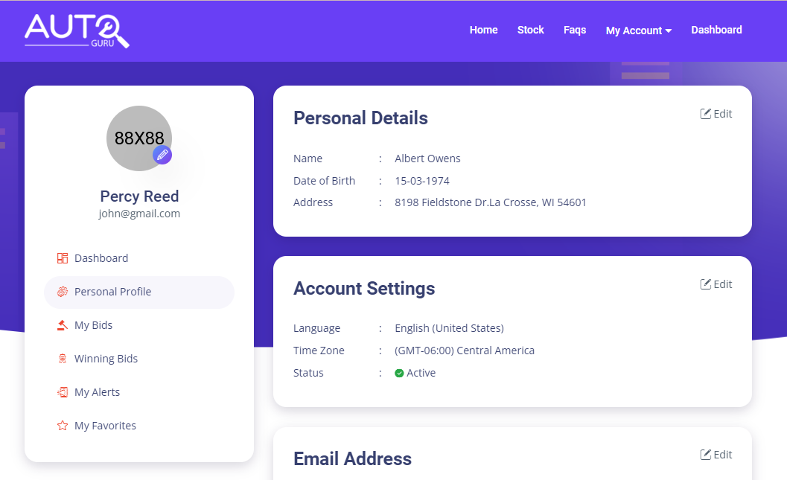

* Overall looks good
* Please remove Date of Birth / language and Time Zone.
* Can they edit their contact details here?

**Admin Panel**

Admin panel will consist of as following pages

* User Management
* New User Management
* New Car Upload
* Car Management
* Offer Insight
* Buy Now Insight
* FAQs Management

-Firstly, there will be login page to make admins access the admin panel.

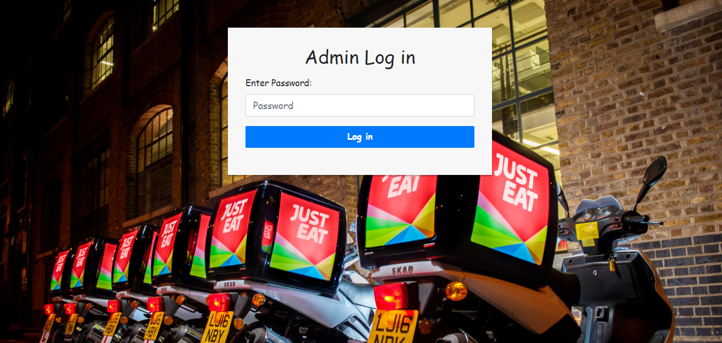

1. **New User management**

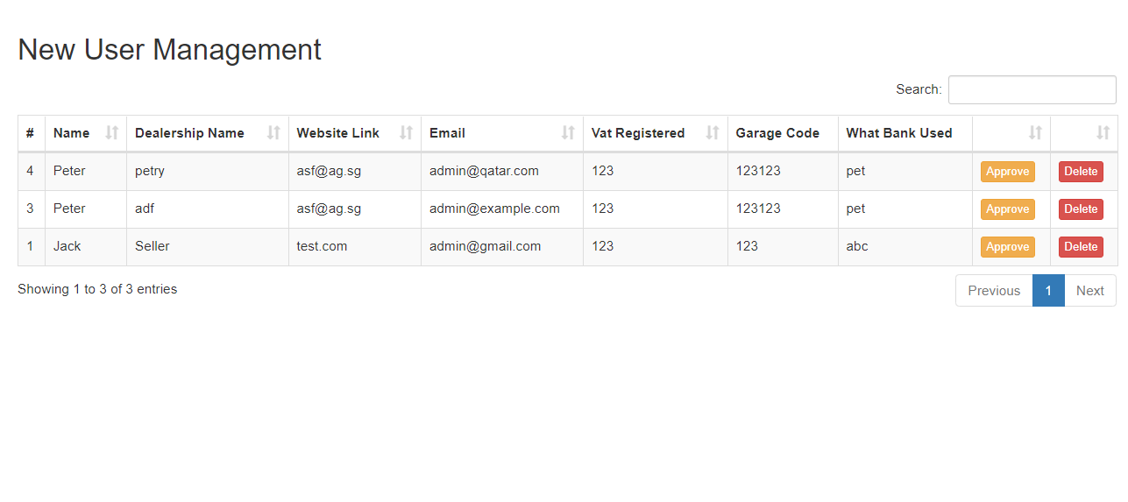

Admins will be able to approve(yellow button) or reject(red button) users who registered newly.

So before you approve a new user, the user can not log in to your website.

Yes this layout and content looks perfect

1. **User management**

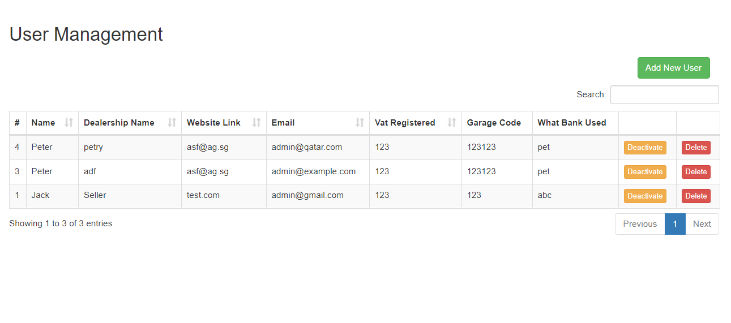

Admins will be able to add new users(green button) or delete users that registered already. And admins will be able to prevent users from logging in temporarily using the deactivate button(yellow). Using the activate button(maybe blue button), able to return users’ s state.

This page will have search function, pagination function, and “order by” function to columns needed.

* The above is correct and they layout / flow looks good

1. **New Car Upload**

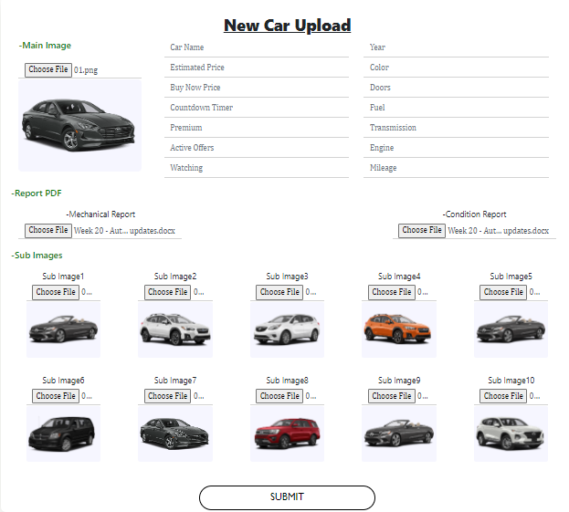

Admins will be able to upload main image, ten sub images, mechanical report pdf and condition report pdf.

And detailed infos such as car name(Model), Estimated price, Buy now price, Countdown timer, Premium, Active users number, Watching users number, Mileage, Engine, Transmission, Fuel, Color, Doors, Year.

The above all looks good

1. **Car Management**

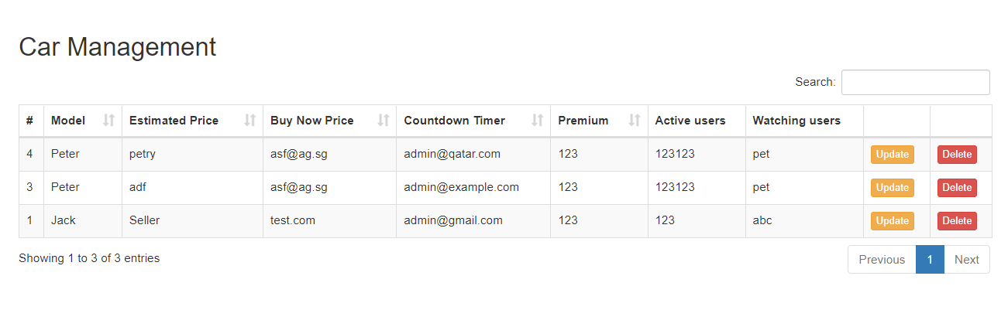

There are the detailed infos of all the vehicles. Admins will be able to update the detailed infos of a particular vehicle using the update button(yellow).

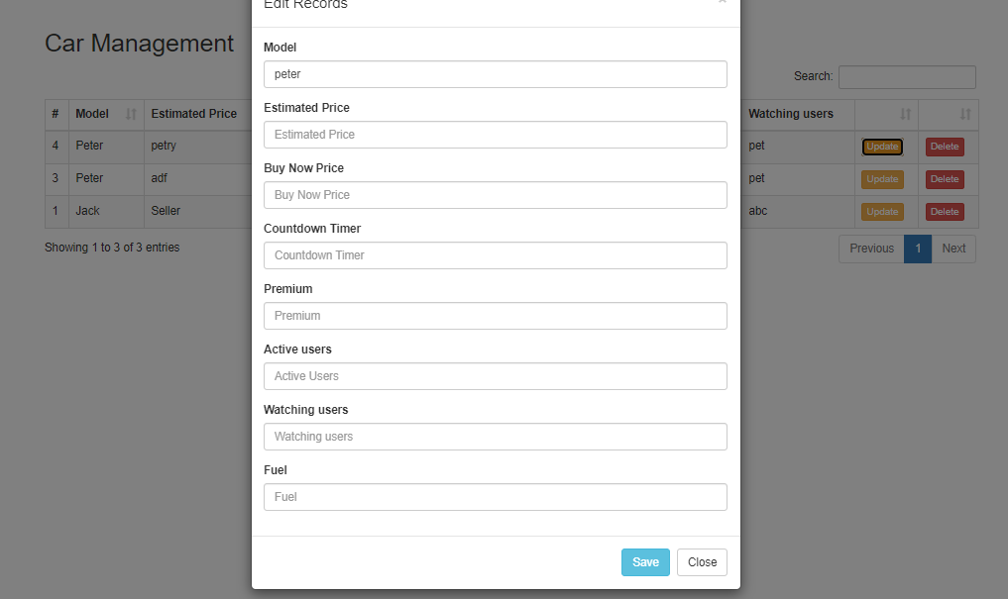

1. **Offer Insight**

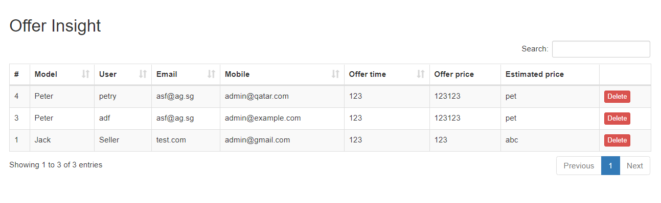

Admins will be able to select a particular vehicle using search function and find highest offer price using “order by” function.

1. **“Buy Now” Insight**

Will be equal to Offer insight page except of showing “buy now” price instead of offer price.

After a buyer has clicked on the buy now they will be shown a confirmation page and the listing will be marked as sold to prevent other users trying to buy it. The listing will remain on the site until the admin removes it.

1. **FAQs Management**

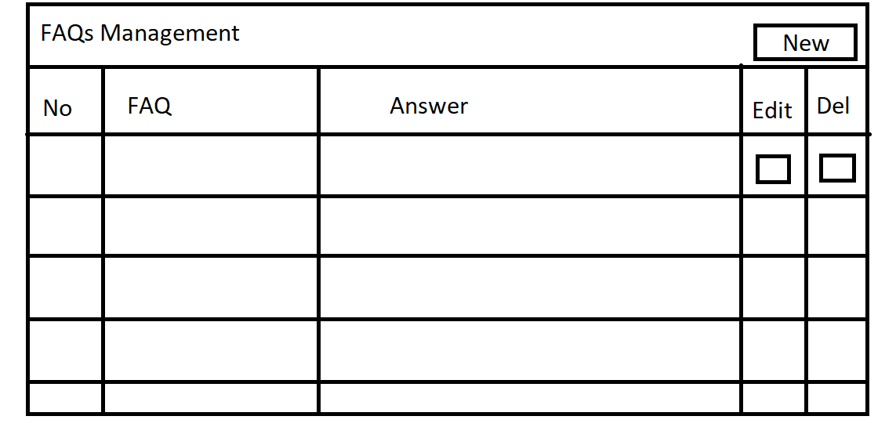

Admin will be able to add new faqs using new button.

Looks Good

**Frontend Modification**

If you are ready with new modification requirements for the frontend now, please send me.

Yes I will get them over asap, they are only some small changes i.e add an image here and there and some additional text

**Testing / Changes**

**Uploading cars to the site:**

1. Can we have it that the ads don't require all 10 images to be uploaded before it can be submitted? As some cars will have less
2. OK. I did so. If you do not choose any sub-image, users will see the main image in the detail page.
3. Some images not showing up when in the listing (a) or on the stock page (b)

2. No. Maybe, it may be network error or local server error. Please refresh the page by pushing F5 button.

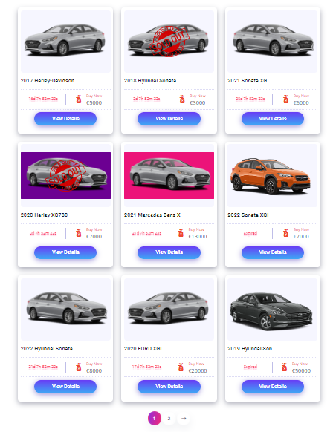

* 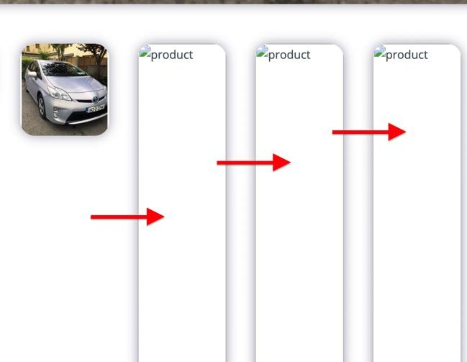

(b)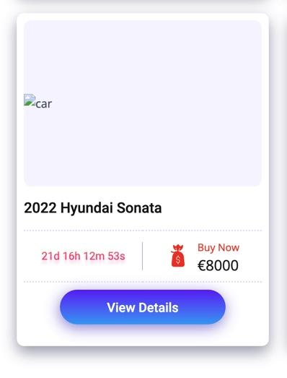

* Picture quality is very grainy / low quality after upload, will this change when live?

Picture quality is not changed when live. You uploaded images with very low quality.

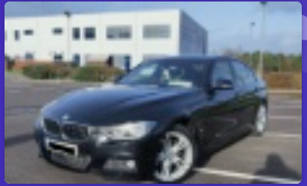

This image dimension is 100*70 and size is 8KB. In fact, the image is the same as the icon size. Normally, jpg image size is 100KB-1MB.

* There is no option to edit the condition when uploading in the admin panel but it shows on the listing

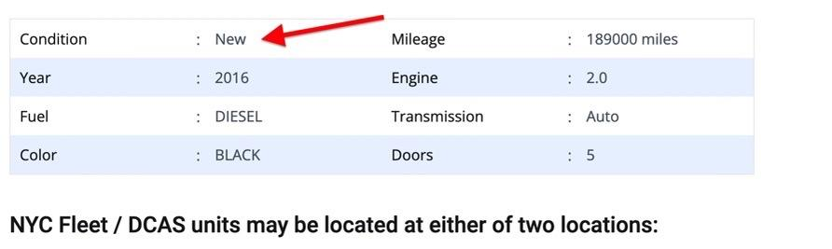

OK. I removed the condition item and door item in the table.

* Can the admin edit this text on the listing if not I’ll send on a script to paste in?

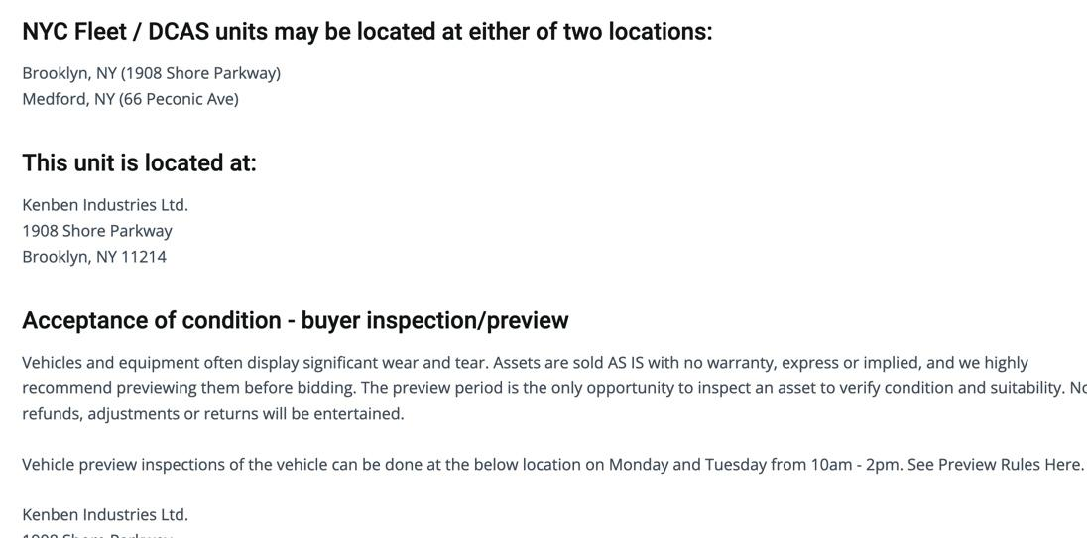

I thought of this text as static, not changeable according to every car. If not, admins should input this text whenever uploading a new car.

So

1. If you want to edit this text, please send me the type of this text. I will increase database and build the controller.
2. If this text is static for all the cars, please send me the script. I will change it.

**Sign up page:**

Looks good

**User logged in:**

For the main part looks good and flows nicely

1. Can we remove the below buttons:

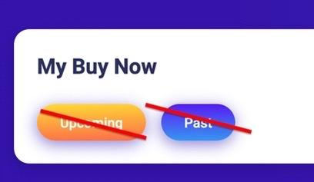

Firstly, the past button was for that user checked cars bought, but expired. I removed two buttons. Two buttons were only for category. Now the user will see all the cars that he bought.

Thanks

1. Winning offers - Will these show in the users section when the admin has accepted the offer?

I thought the highest offer price among offers as winning offer. I ‘ ve changed winning offer.

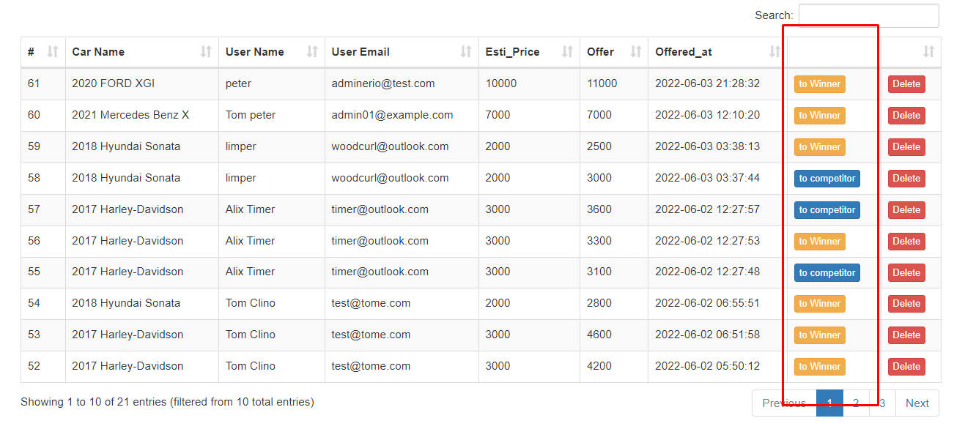

Those that you selected will become as winning offers.

Perfect

**Contact us:**

* Not sure what the below image is but it isn't loading, can you add some generic contact us image.

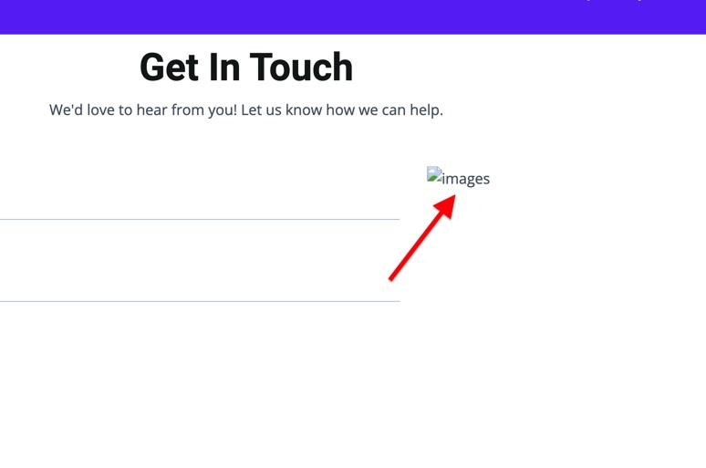

**There is one image already in that page.**

**Ok it mustn’t have loaded**

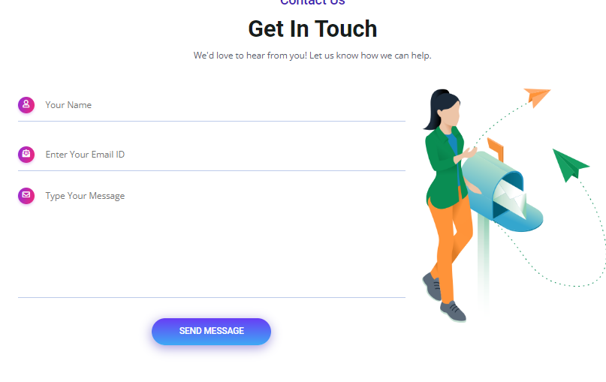

* After clicking submit the below text shows

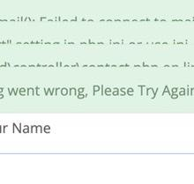

In the local server, the mail sending function can not work because of no being a mailto server. It will work well in your hosting server.

* Will you set the contact us to go to [info@autoguru.ie](mailto:info@autoguru.ie)

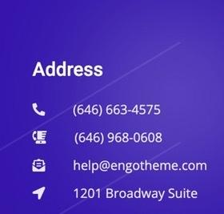

Address:

Ladytown Business Park,

Naas,

Co. Kildare

Ireland

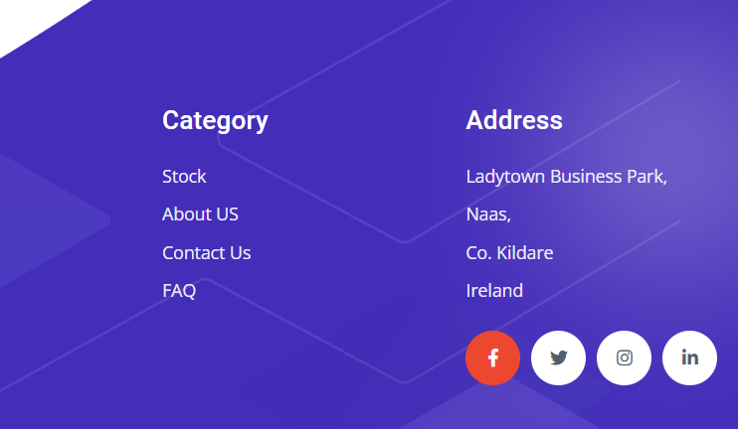

**Friday 17/06/22**

* Admin page login.

Can we remove the Just Eat image and keep it blank or add another generic image

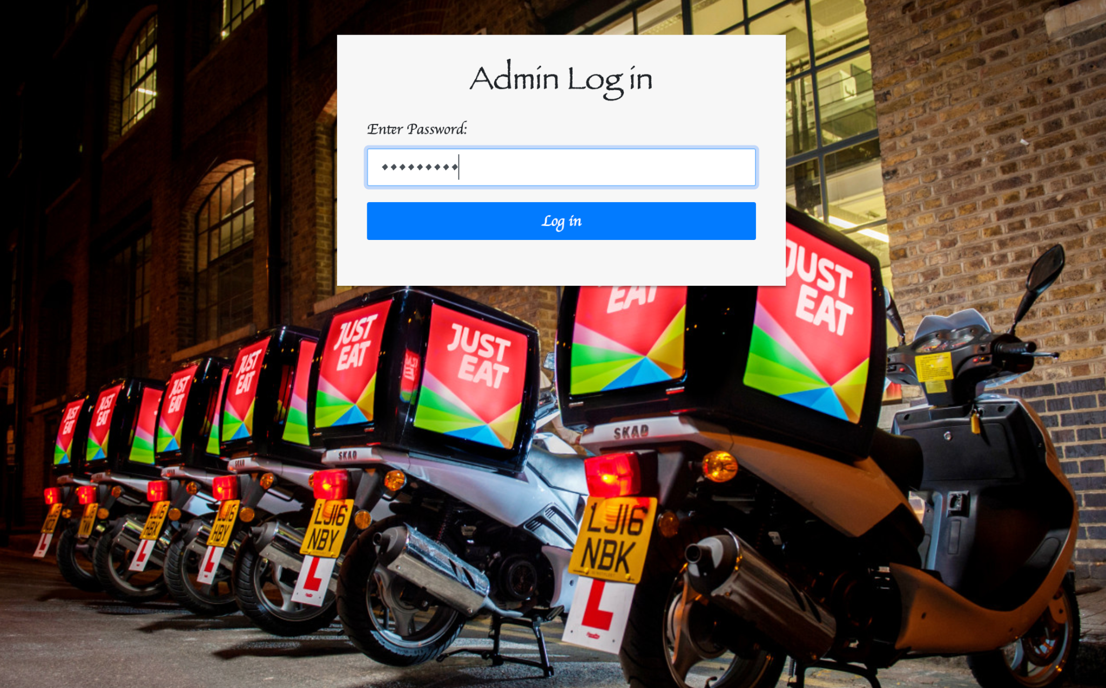

* After clicking the mechanical report or conditional report the below error comes up 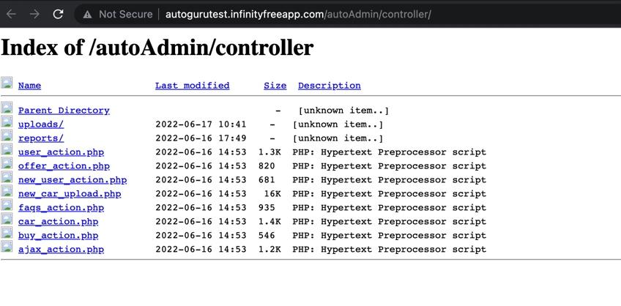
* In the text section on each listing can we replace the below text with

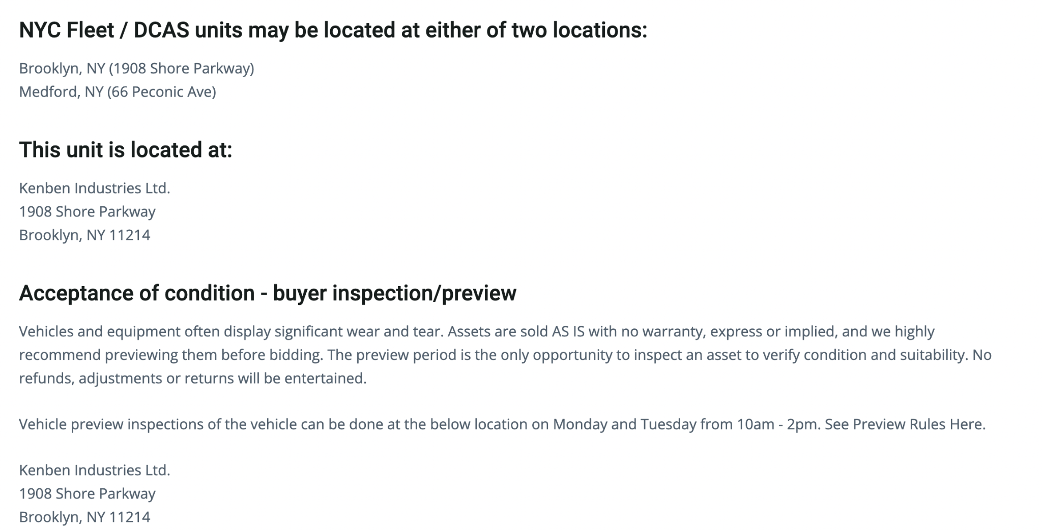

With:

**Sold As Seen**

All our cars are “*SOLD AS SEEN*” which means that they are sold with all its faults and carries no guarantee whatsoever, and cannot be replaced under any circumstances. But don't let this put you off! All our cars come with a mechanical and conditional report, use these to inform yourself of what a car may need.

**Submit An Offer**

Submit an offer are timed sales and will display a countdown timer on the listing. You can place your maximum offer at any time before the timer has finished. Will inform the highest offer when the timer finishes. Alternatively you can **Buy Now.**

**Buy Now**

Buy vehicles instantly at a fixed price day or night. Once you have found the vehicle you would like to buy click on **Buy Now**. You will need to click on Buy Now again. The vehicle is now yours and be marked as sold on the stock page, it will show on your Dashboard under the Buy Now section. Shortly after purchasing you will receive an email with the invoice attached for payment.

**Mechanical Reports**

30+ point mechanical assessments are undertaken on all vehicles by trained inspectors at our remarketing centre. The report gives you a snapshot of a vehicle’s mechanical condition at the point in time when the assessment took place. The vehicles are left to idle for 5 minutes and taken for a 2km test drive to 3rd gear.

* When the inspectors look at the engine no engine covers are removed.
* The assessment is carried out at ground level, not on a ramp, so oil leaks or defects below the vehicle cannot be seen.
* The inspectors only connect an engine diagnostic code reader to a vehicle if the engine management light is illuminated.

**Conditional Reports**

Our condition grading allows you to easily identify a cars condition, as well as helping you understand how condition affects different cars.

* After a car has sold via the BUY NOW route can the price be removed from the listing

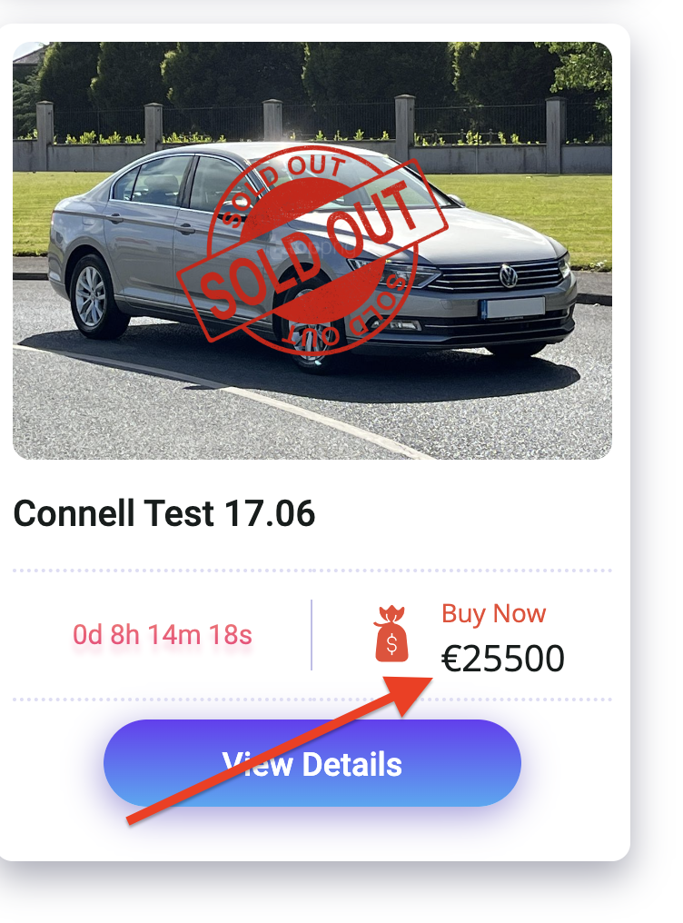

* Can we remove the below button

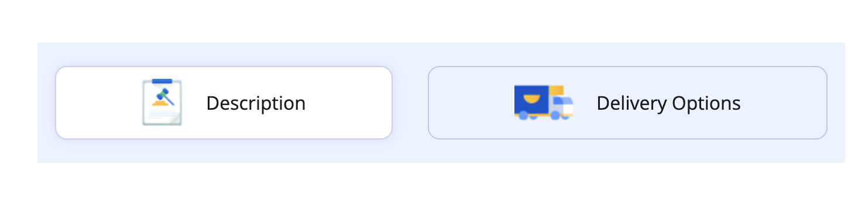

* **Is it possible to change the Sold logo from:**

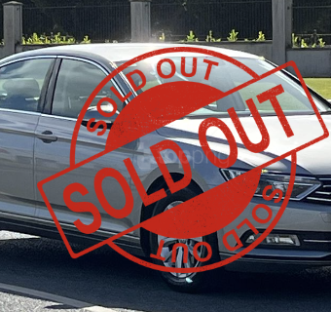

To: 

* **When trying to enter the FAQ page to make changes the below shows**

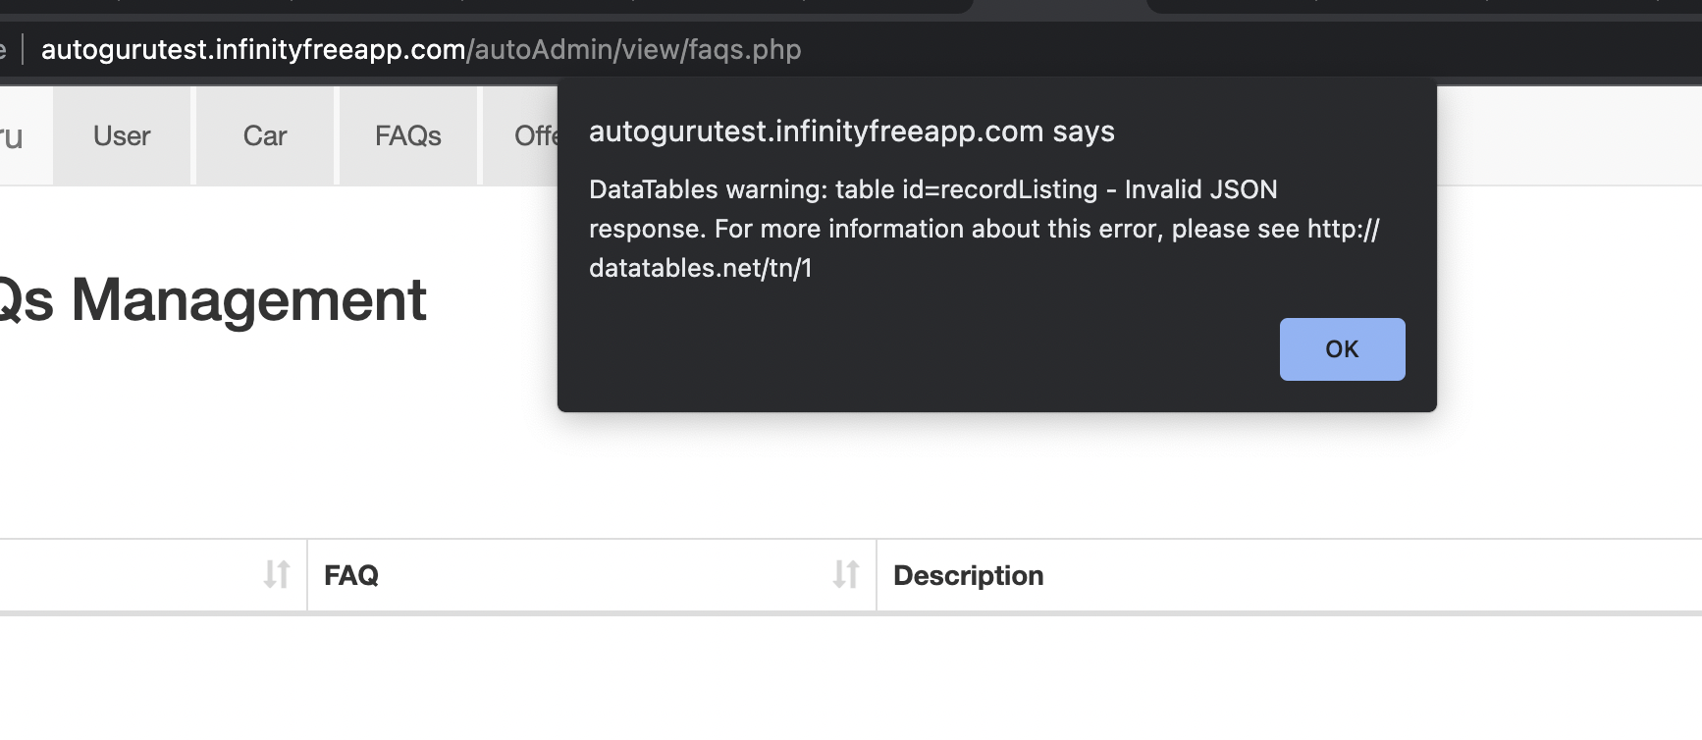

* **How does the admin delete an old listing from the page?**

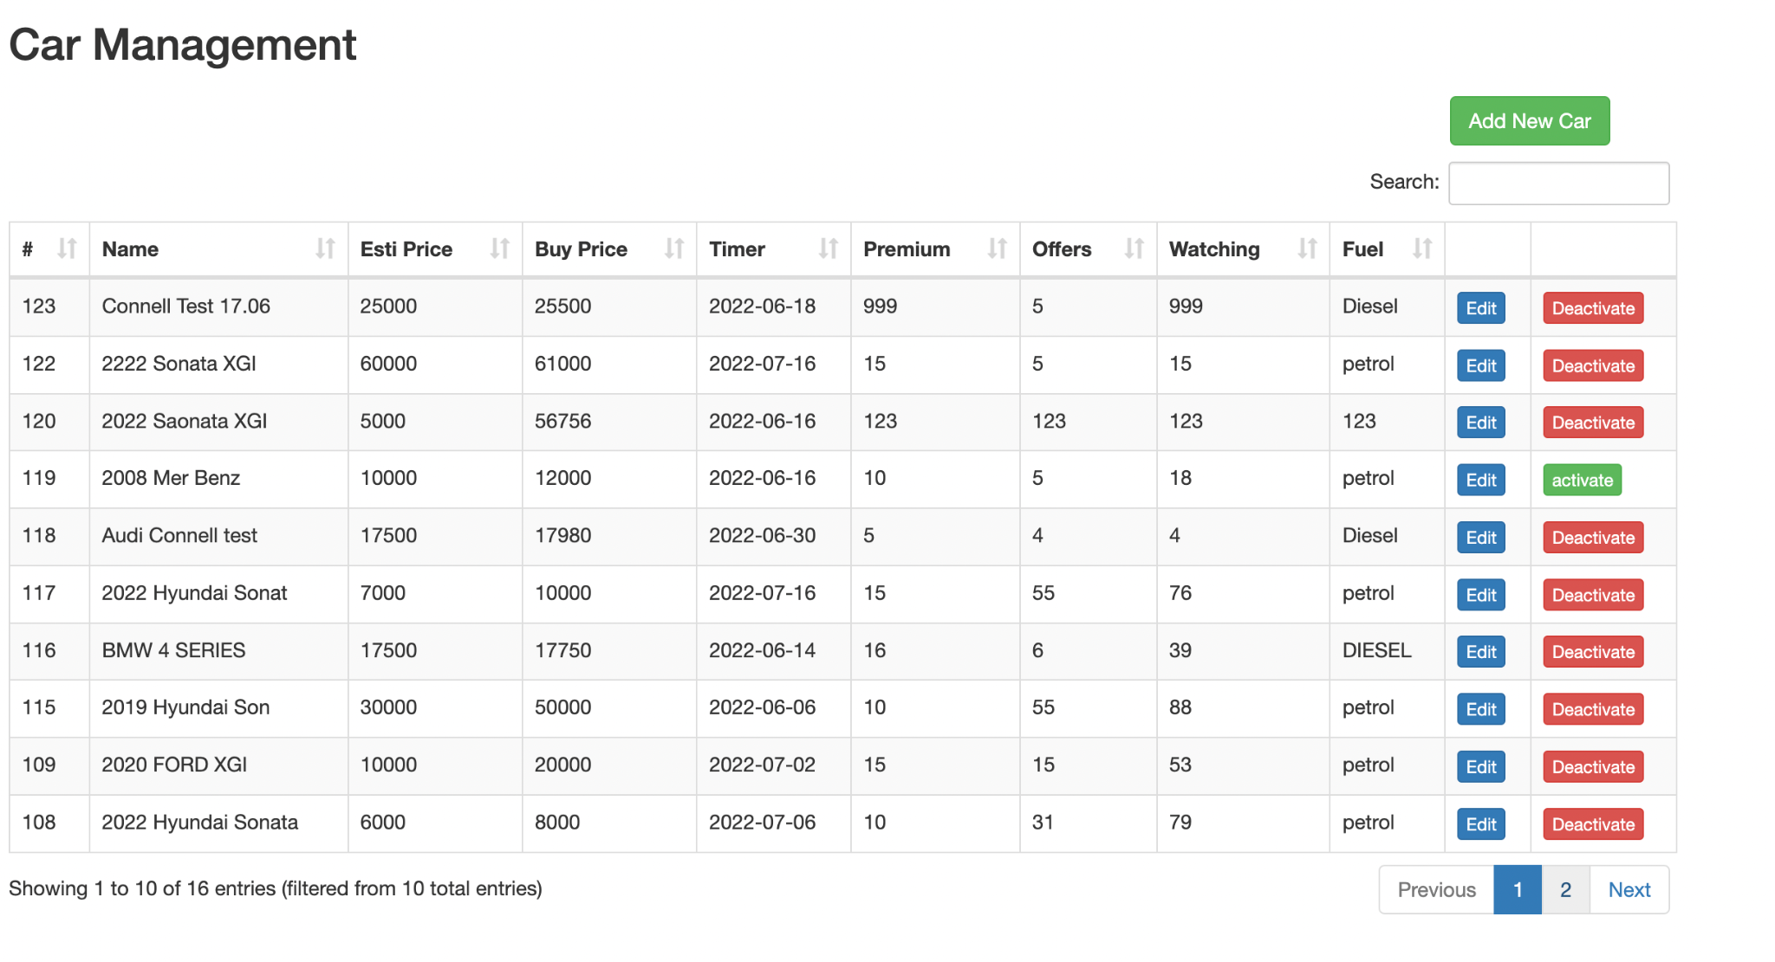

* **How does the admin select which cars show on the featured section on the homepage?**